Model Based Design

//

TBD CREATE AN INTRO

//

**Phase 1:**

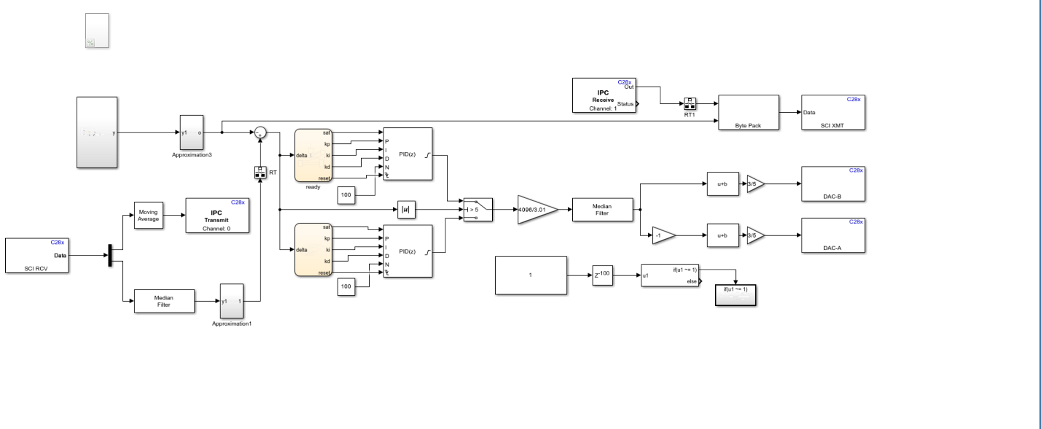We used the designs which were previously made to generate code that will be deployed to CPU1 of our F28379D board.

Figure 1: Model Based Design of the control algorithms running on our F28379D board inside our MATGR DB-4 car.

The code generator creates a build folder in your working folder to store generated source code. The build folder contains object files, a makefile, and other files created during the code generation process. The default name of the build folder is model_ert_rtw. [1]

Figure 2: Code Modules and Header Files Affected by File Packaging

Our focus will be on our model.c, which contains

References

[1] Manage File Packaging of Generated Code Modules (no date) Manage file packaging of generated code modules - MATLAB & Simulink. Available at: https://www.mathworks.com/help/ecoder/ug/generate-code-modules.html (Accessed: 01 March 2024).